Worksheet 1.3

Student Name: Sahil Kaundal UID: 21BCS8197

Branch: CSE (Lateral Entry) Section/Group:20BCS-809_A Semester: 4th Date of Performance: 04/03/2022

Subject Name: Programming in Python Lab Subject Code: 20CSP-259

1. Aim/Overview of the practical:

* Write a python program to calculate area of 10 different circles. Given the pie = 22/7 and radius of the circles entered by user using Simple Function, Parameterized Function, Return Type with function and return type with parameterized Functions.
* Write a python program to print Multiplication tables from 2 to 20 whether table values entered by user using Simple Function, Parameterized Function, Return Type with function and return type with parameterized Functions.

1. Task to be done/ Which logistics used:



* Python program to calculate area of 10 different circles. Given the pie = 22/7 and radius of the circles entered by user using Simple Function, Parameterized Function, Return Type with function and return type with parameterized Functions.
* Python program to print Multiplication tables from 2 to 20 whether table values entered by user using Simple Function, Parameterized Function, Return Type with function and return type with parameterized Functions.

1. Steps for experiment/practical/Code:

* Python program to calculate area of 10 different circles.

def findarea(radius): pi = 22/7

area_of_circles = pi * radius * radius print("The area of circle is ",area_of_circles)

r = int(input("enter Radius of circle : ")) findarea(r)

* Python program to print Multiplication tables from 2 to 20

def print_table(num):

""" This function prints multiplication table of a given number"""

for i in range(2,21): print(num,' x ', i, ' = ',num*i)

# end of function table

# input a number

n = int(input("Please Enter a number to print its multiplication table:"))

print_table(n)

1. Result/Output/Writing Summary:

* Python program to calculate area of 10 different circles.

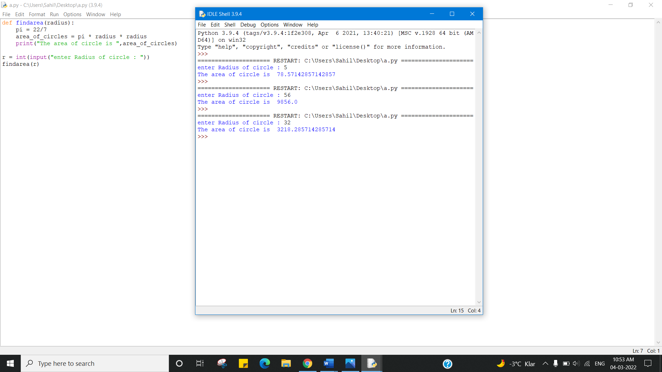

* Python program to print Multiplication tables from 2 to 20

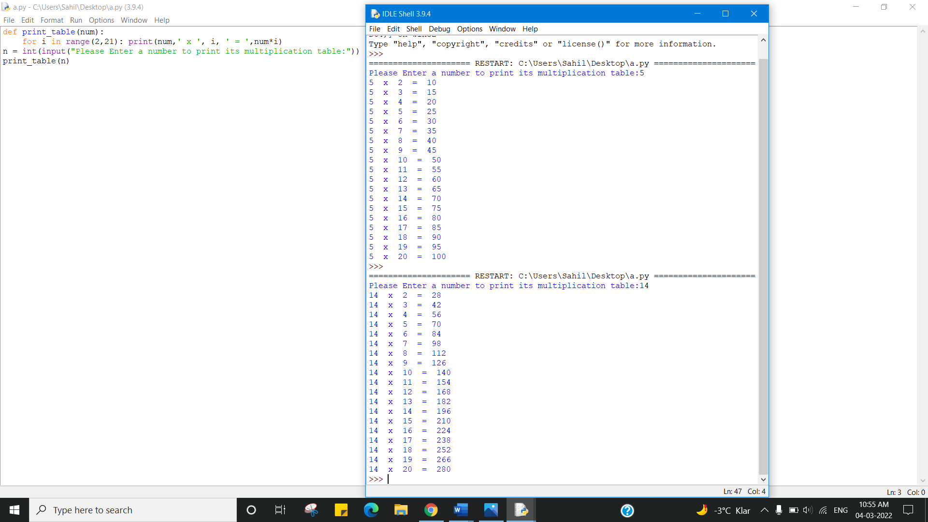

Learning outcomes (What I have learnt):

1. Python program to calculate area of 10 different circles.
2. Python program to print Multiplication tables from 2 to 20

Evaluation Grid (To be created as per the SOP and Assessment guidelines by the faculty):



|  |  |  |  |
| --- | --- | --- | --- |
| Sr. No. | Parameters | Marks Obtained | Maximum Marks |
| 1. |  |  |  |
| 2. |  |  |  |
| 3. |  |  |  |